INSY 8413: Web Technologies & Modern Frontend Architectures (Vue.js) Task-buddy Frontend URL :https://task-buddy-fe.netlify.app/

Course Introduction & Project Overview: Task-Buddy
This material covers advanced web application architecture using Task-Buddy, a single- page application (SPA) built for this module. We will dissect its codebase to understand modern frontend development principles.

Key Technologies
Vue 3 (Compound API): Component-based logic.
Vite: Next-generation build tool (ES Modules).
Tailwind CSS: Utility-first CSS framework.
Pinia: State management (replaces Vuex).
Vue Router: Client-side routing.

Single Page Applications (SPA) Concept
In traditional web applications (MPA), clicking a link causes the browser to request a new HTML page from the server, resulting in a full reload.
SPA (Task-Buddy) loads a single HTML file (
index.html) and dynamically updates the content using JavaScript. This provides a smoother, "app-like" experience.

Key File Analysis:
src/main.js
This is the entry point. It creates the Vue app instance and mounts it to the DOM (#app in
index.html).

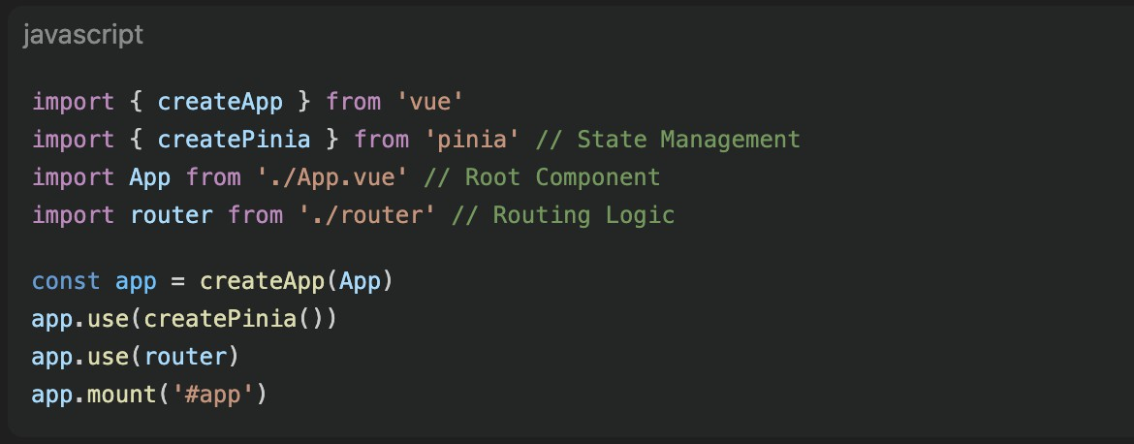

Component-Based Architecture (Vue 3)
Modern web development breaks UIs into reusable Components.
Task-Buddy uses the Composition API, which groups logic by concern rather than by option type (data, methods).
Summary Table for Students:

Feature | Direction | Real-World Task-Buddy Use
Props | Down (Parent → Child) | Passing the Task title to the item component.
Emit | Up (Child → Parent) | Clicking "Delete" in the item to update the main list.
onMounted | Timing (Lifecycle) | Loading the list from memory when the app starts.
Async/Await | Timing (Performance) | Waiting for a database to save a new task.

Props: "The Parent Speaks"

Concept: Props (Properties) are how a Parent component passes data down to a Child.
Task-Buddy Example: The Parent (App.vue) has a list of 10 tasks. It loops through them and gives each individual task to a TaskItem.vue component.
Analogy: A parent giving a child a lunchbox. The child can eat the food (display it), but they didn't make the food themselves.
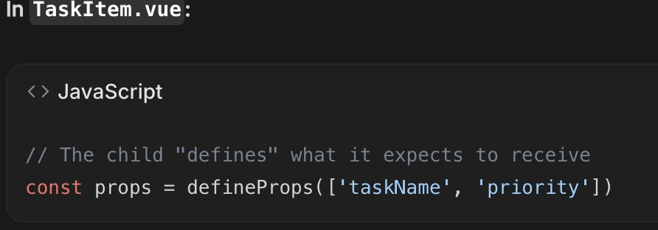
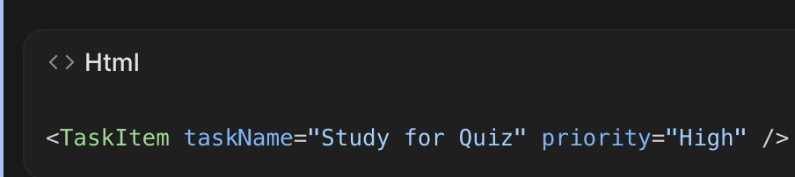

Emit: "The Child Speaks"
Concept: Emits are how a Child component sends a signal up to the Parent.
Task-Buddy Example: When a student clicks "Delete" on a specific TaskItem, the child can't delete itself (it doesn't own the list). It must emit an event to tell the Parent: "Hey! Delete me!". Analogy: A child raising their hand in class to tell the teacher (the parent) something happened.

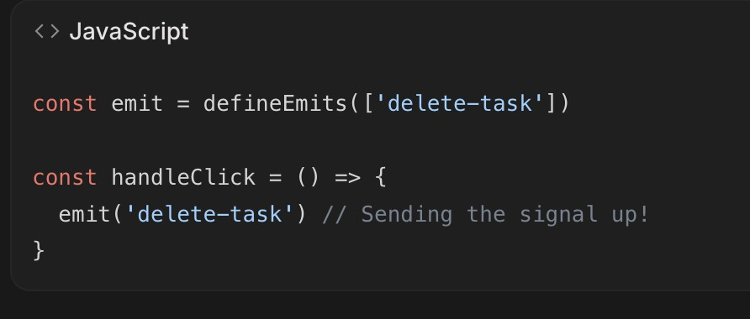

Mounted: "The Alarm Clock"
Concept: onMounted is a lifecycle hook. It runs code the very moment the component appears on the screen.
Task-Buddy Example: When the user opens the website, Task-Buddy needs to load saved tasks from a database or LocalStorage immediately.
Analogy: The moment you wake up (Mount), the first thing you do is check your phone (Load data).
In App.vue:
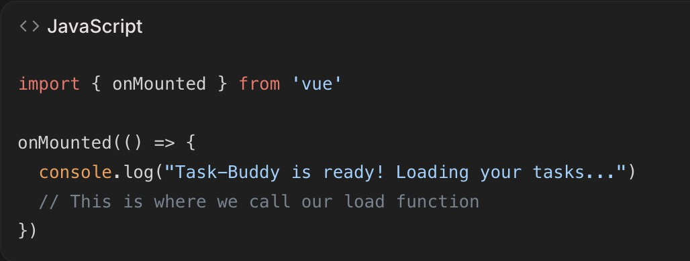

Async / Await: "The Waiting Game"
Concept: Used for actions that take time (like fetching data from the
internet). Async says "this function will take time," and Await says "pause here until the data arrives."

Task-Buddy Example: If Task-Buddy saves tasks to a server, the app shouldn't "freeze" while waiting for the server to reply.
Analogy: Ordering coffee. You order (Async), you wait for your name to be called (Await), and then you drink it. You don't just stand frozen at the counter!
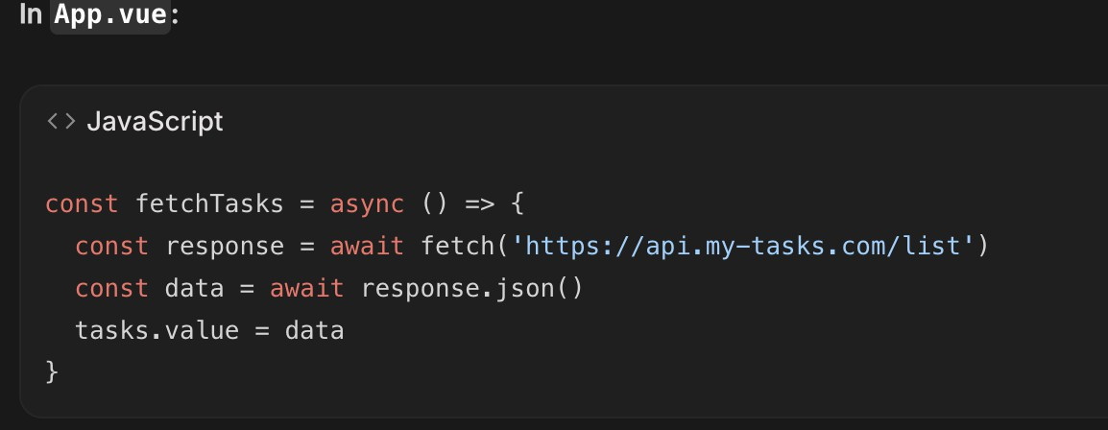

Sync (Data Consistency)
Concept: In the context of Web Tech, "Sync" usually refers to keeping the UI in sync with the data (Reactivity).
Task-Buddy Example: If you delete a task from the tasks array, the HTML list should disappear instantly. You don't need to refresh the page. This is Vue's "Reactive Sync."

Example:
TaskCard.vue This component handles the display of a single task. It accepts data via props and communicates back to the parent via emits.

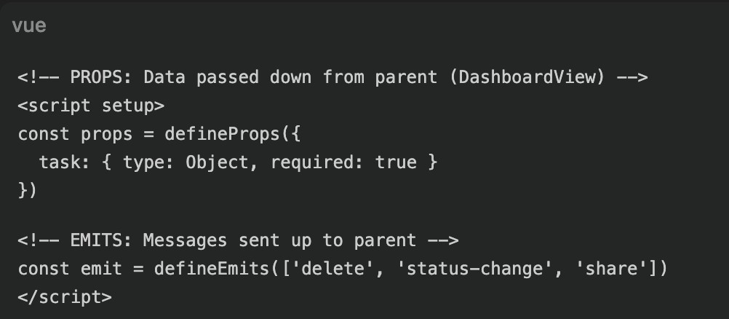

Concept Check: Why use emits?
Unidirectional Data Flow: Data flows down (Props), Events flow up (Emits). The child component (TaskCard) should not modify the task directly; it asks the parent
(TaskStore via DashboardView) to do it.

State Management (Pinia)
When multiple components need to share state (e.g., the list of tasks needs to be accessed by DashboardView, StatsView, and TaskCard), we use a Global Store.
File: src/stores/tasks.js Core Concepts:
State: The raw data (tasks, filter).
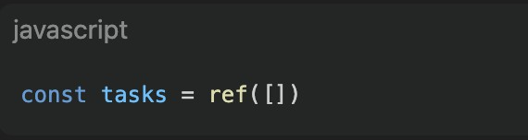

To explain const tasks = ref([]) to students, it is best to break it down into three parts: The Syntax, The "Magic" (Reactivity), and The Rules.
Here is a student-friendly explanation:

1. The Breakdown
const: We use const because the "box" (the reference) stays the same, even if the items inside the list change.
tasks: This is simply the name of our variable. Since it’s a list of things to do, we name it plural.
ref: This is short for Reference. It tells Vue: "Keep an eye on this variable. If it changes, update the website immediately."
([]): This is the starting value. We are starting with an empty array (a blank list).

Getters (Computed): Derived state. For example, filteredTasks automatically updates when filter or tasks changes

const filteredTasks = computed(() => { ... })

Actions: Functions that modify state (addTask, deleteTask). javascript code:

function addTask(task) { tasks.value.push(task) }
Why Pinia? It allows us to decouple business logic from UI components.
The DashboardView.vue doesn't know how to save a task to localStorage; it just calls taskStore.addTask().

Routing & Navigation Guards
Users expect standard navigation (back button, URLs). Vue Router simulates this.

File:
src/router/index.js Dynamic Routing
We use a dynamic segment :filter? to handle different views with one component.

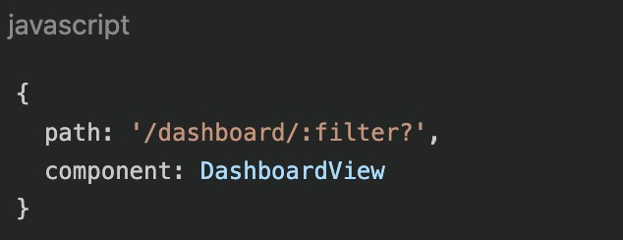
- /dashboard -> Shows All
- /dashboard/todo -> Shows To Do
- /dashboard/completed -> Shows Completed

Navigation Guards (Security)
We protect routes using meta: { requiresAuth: true } and a global guard.
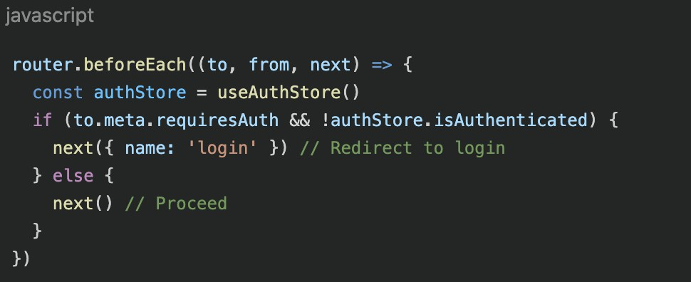

Styling Paradigm: Utility-First (Tailwind CSS)

Instead of writing custom CSS classes like .sidebar-container, we use utility classes directly in the HTML.
Traditional CSS:
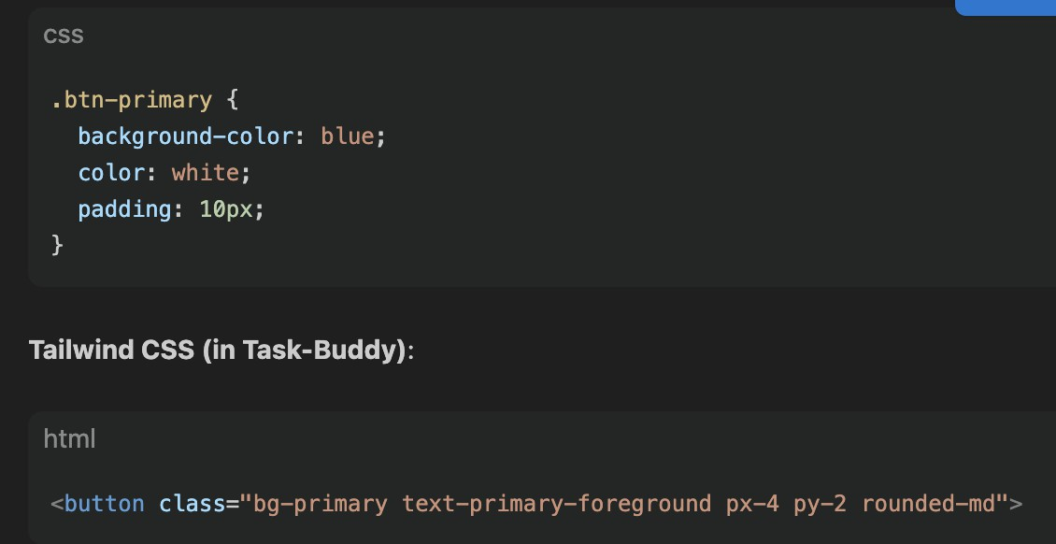

Project Structure & Organization
Understanding the folder structure is crucial for scalable Vue.js development. Here is how Task-Buddy is organized:

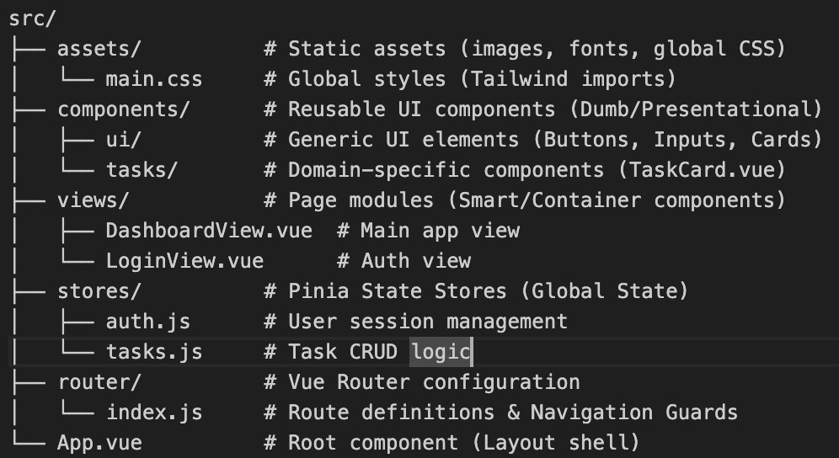

Best Practices:
Views vs Components: `views` are pages connected to a route. `components` are reusable parts.
Store Independence: Logic should live in `stores`, not components. Components just
trigger actions.
Asset Management: Use `assets` for code-imported media. Use `public` for static files (robots.txt, favicon).

Benefits:
Speed: No context switching between HTML and CSS files.
Consistency: We use a design system (defined in tailwind.config.js or CSS variables) ensuring all spacing/colors match.

Student Exercises
To reinforce these concepts, try implementing the following features in Task-Buddy:

Exercise A: "Clear Completed"
Add an action clearCompleted() in src/stores/tasks.js.
Create a button in DashboardView.vue that triggers this action. Challenge: Only show the button if there are actually completed tasks. Exercise B: User Profile Page

Create a new view ProfileView.vue.
Add a route /profile in router/index.js (guarded by auth).
Display the current user's info (from AuthStore) and allow them to edit their "Bio".

Exercise C: 404 Page
Create a NotFound.vue view.
Add a catch-all route /:pathMatch(.*)* at the end of your router configuration.

ExercisesD

Level 1: Beginner (Frontend Only)
Goal: Build the static UI with mocked data.
- Layout: Create a responsive Dashboard layout using Tailwind Grid/Flex.
- Components: Build a `TaskCard.vue` component that accepts props (title, status).
- Styling: Implement a "Dark Mode" toggle using Tailwind's `dark:` modifier.

Level 2: Intermediate (Full Stack)
Goal: Connect Frontend to Backend and handle data.
- API Integration: Replace mock data with real API calls using Axios.
- Auth Flow: Implement Login/Register pages with JWT storage in `localStorage` (securely).
- CRUD: Create a form to Add/Edit tasks with validation (e.g., date cannot be in the past).

Level 3: Advanced (Security & A11y Expert) Goal: Harden the application and ensure compliance.
- RBAC: Implement "Task Sharing". Users can only see tasks shared with them. Enforce this in Spring Boot Security.
- A11y Audit: Ensure the entire app passes a WAVE/Lighthouse audit with 100% score. Add "Skip to Content" links.
- Optimization: Implement lazy loading for routes and image optimization.

Accessibility Verification Checklist (WCAG 2.1 AA)

Semantic HTML: Use `<nav>`, `<main>`, `<article>`, `<button>` correctly. No `div` buttons!

Keyboard Nav: Can you use the app with ONLY `Tab`, `Enter`, `Space`, and Arrow keys?
Focus Indicators: Is the current focus visible? (No `outline: none` without replacement).
Color Contrast: Text vs Background ratio (4.5:1 for normal text).
Alt Text: All meaningful images have `alt` attributes. Decorative icons have `aria- hidden="true"`.
Forms: All inputs have associated `<label>` elements. Error messages are linked via
`aria-describedby`.

Security Best Practices Checklist
Authentication: Never store plain-text passwords (use BCrypt).
Authorization (RBAC): Verify user ownership of an ID before updating/deleting (Don't trust the ID in the URL!).
XSS Prevention: Let Vue handle escaping. Avoid `v-html` unless absolutely necessary and sanitized.
API Security: Rate limiting (Resilience4j) and CORS configuration (restrict to frontend domain).
Environment: Store secrets (DB URI, JWT Secret) in `.env` files, NEVER in git.

Deep Dive: Vue.js Security & XSS Prevention
Cross-Site Scripting (XSS) is the most common vulnerability in frontend apps. Vue protects you by default, but you must use it correctly

Interpolation (Safe by Default)
Vue automatically escapes HTML in double curly braces.
```html
<!-- SAFE: Renders as plain text -->
<span>{{ userProvidedInput }}</span>
```
If `userProvidedInput` is `<script>alert(1)</script>`, Vue renders it simply as the text string, not executable code.

The Danger Zone: `v-html`
Using `v-html` bypasses Vue's escaping. **Avoid this** unless specifically rendering trusted HTML (e.g., from a CMS).
```html
<!-- DANGEROUS: Executes scripts if content is tainted -->
<div v-html="userProvidedInput"></div>
```
Best Practice: If you MUST use `v-html`, sanitize the input first using a library like

DOMPurify.
```javascript
import DOMPurify from 'dompurify';
const cleanContent = DOMPurify.sanitize(dirtyHTML);
```

Attribute Binding Injection
Be careful when binding URLs. `javascript:` pseudo-protocols can execute code.
```html
<!-- DANGEROUS if url is "javascript:alert(1)" -->
<a :href="url">Click me</a>
```
Best Practice: Validate protocols (http/https only) before binding.

Direct DOM Access
Avoid accessing `refs` to inject HTML manually.
```javascript

AVOID THIS

this.$refs.myDiv.innerHTML = userInput;
``

